Title of the Paper

First Author¹ (ORCID), Second Author^{2*} (ORCID), Third Author^{1,2} (ORCID)

¹ Affiliation (Institution/University)
² Affiliation (Department, Faculty/College, Institution/University)
* Corresponding author’s email:

DOI: Here will be added DOI number by Glottometrics.

ABSTRACT
The article should contain an abstract within 200 words. The abstract states briefly the purpose of the research, methodology, key results, and major conclusions. The abstract should be a citation-free single paragraph with running sentences. Format: Times New Roman, 10 pt., justified paragraph, automatic hyphenation, line spacing 1.5, style: Abstract&KeyWords.

Keywords: 3-5 keywords separated by commas.

Introduction
The paper must be written in English and checked by a native speaker. The paper should not be longer than 20 pages (including title page, references, appendix).
The introduction contains the goal of the research. Format: Times New Roman, 11 pt., justified paragraph, automatic hyphenation, line spacing 1.5, style: Text.
Chapter heading format (level 1): Times New Roman, 14 pt., left-aligned paragraph, automatic hyphenation, boldface, style: Heading 1. Other levels of chapter headings: Times New Roman, 11 pt., left-aligned paragraph, automatic hyphenation, boldface, styles: Heading 2, 3.
The citations include the surname of the author and the date of publication only. Using an example author James Brown, this takes the form Brown (2017) states… or (Brown 2017). Two authors: (Brown and Smith 2017). More than two authors: (Brown et al. 2017). The direct quote citation must follow the quote directly and contain a page number after the date, for example: (Brown 2017, p. 104), (Brown, 2017, pp. 104-112). Authors with multiple works from one year should be cited with a, b, c... following the date. For example: (Brown 2017a).
Citing multiple works in one parenthesis by the same author, the surname is stated once followed by the dates in order chronologically. For instance: (Brown 2007, 2013, 2017). If the works are by multiple authors then the references are ordered alphabetically by the first author separated by a semicolon as follows: (Brown and Smith 2017; Thomson et al., 2015; Wang 2020a, 2020b).

Material
This chapter (Material, Corpus, Data…) should contain a detailed description of the corpus/data. The data should be freely available to all for use unless there is a serious reason not to do so (this reason should be explained). The data should be ideally available on some online data repository such as GitHub, CLARIN, etc.

Methodology

Equations and Formulas
Mathematical equations and expressions should be inserted using equation tool of MS Word. References may be added for used equations, e.g. the texts have been analyzed using Gini coefficient (1).

- $G=\frac{1}{V}\left(V+1-\frac{2}{N}\sum_{r=1}^{V}{rf\left(r\right)}\right)=\frac{1}{V}\left(V+1-{2m}_{1}^{'}\right)$

Results
This section should present the results of the research.

Preparation of Figures and Tables
Authors are supposed to embed all figures and tables at the appropriate place within the manuscript. Figures and tables should neither be submitted in separate files nor add at the end of the manuscript. Figures and Tables should be numbered properly with a descriptive title. Each Figure/Table must be explained within the text by referring to the corresponding figure/table number, e.g. see Table 1, see Figure 1.

Formatting Tables
Tables should be prepared using MS Word (they cannot be inserted as bitmap graphics). Every table must have a numbered caption (above the table) and must be cited somewhere in the paper, e.g. the word list can be seen in Table 1. Format of captions: Times New Roman, 9 pt., centered paragraph, style: Caption. Table format: Times New Roman, 9 pt., centered paragraph, header in boldface, style: Table.

Table 1: First 10 tokens in Text 1.
Token | Rank | Frequency
the | 1 | 16
it | 2 | 7
was | 3 | 7
of | 4 | 7
and | 5 | 5
a | 6 | 5
for | 7 | 3
you | 8 | 3
at | 9 | 3
face | 10 | 3

Formatting Figures
Figures should be used in bitmap formats (TIFF, GIF, JPEG, PNG, etc.) with 300 dpi resolution at least. Every figure must have a numbered caption (below the figure) and must be cited somewhere in the paper, e.g. Figure 1 shows the Glottometrics cover page. Format of captions: Times New Roman, 9 pt., centered paragraph, style: Caption. Format of figures: centered, style: Figure.

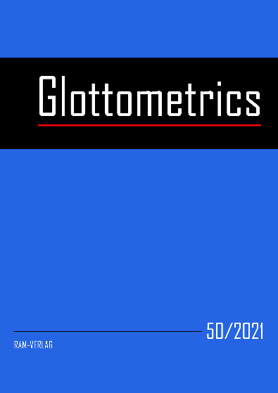
Figure 1: Glottometrics cover page.

Conclusion
Conclusion section should contain the main outcome of the research, limitation, application, and recommendation.

  - Acknowledgements
This part is dedicated mainly to funding information. For example: This research is supported by the Scientific Grant Agency of the Ministry of Education, Science, Research and Sport of the Slovak Republic and of the Slovak Academy of Sciences (VEGA 2/0054/18).
  - References
Format: Times New Roman, 10 pt., left-aligned paragraph, no automatic hyphenation, line spacing 1.5, style: References, authors in boldface. See examples below. Include DOI number if available.
Altmann, G., Čech, R., Mačutek, J., Uhlířová, L. (Eds.). (2014). Empirical Approaches to Text and Language Analysis: Dedicated to Ludĕk Hřebíček on the Occasion of His 80th Birthday. Lüdenscheid: RAM-Verlag.
Grieve, J. W. (2005). Quantitative authorship attribution: A history and an evaluation of techniques. Simon Fraser University. (MA thesis)
Köhler, R. (2014). The fractal structure of linguistic motifs. In: Altmann, G., Čech, R., Mačutek, J., Uhlířová, L. (Eds.). Empirical Approaches to Text and Language Analysis: Dedicated to Ludĕk Hřebíček on the Occasion of His 80th Birthday, pp. 94-104. Lüdenscheid: RAM-Verlag.
Kubát, M., Milička, J. (2013). Vocabulary richness measure in genres. Journal of Quantitative Linguistics, 20(4), pp. 339-349. https://doi.org/10.1080/09296174.2013.830552.
Richter-Altmann, J. (2020). Gabriel Altmann's Bibliography. Retrieved from http://www.ram-verlag.biz/wp-content/uploads/2019/06/Bibliographie.pdf (Accessed on May 8, 2020).
Yule, G. U. (1944). A Statistical Study of Literary Vocabulary. Cambridge: University Press.
  - Appendix

We prefer only University/Institution. Department, Faculty/College is optional.

